Database Task

INSERT INTO Dbo.Company (Name, SpecialistIdId)

VALUES ('Vanja', '697558d8-4d0b-4a71-97ad-59d0fe29ab56');

INSERT INTO Dbo.Company (Name, SpecialistIdId)

VALUES ('Mari', '87f8fc6a-430f-4aab-bf6d-4d2fa87065c5');

INSERT INTO Dbo.Company (Name, SpecialistIdId)

VALUES ('Karl', 'a4d18c6a-652a-4fe3-85ca-2239b2b2e5d5');

INSERT INTO Dbo.Company (Name, SpecialistIdId)

VALUES ('Indrek', '15acce71-080d-4153-964e-4a7d7f8a795e');

INSERT INTO Dbo.Company (Name, SpecialistIdId)

VALUES ('Marek', 'ed447dcb-7d39-4a89-93d4-ae75291a046f');

INSERT INTO Dbo.Company (Name, SpecialistIdId)

VALUES ('Maie', '56caba23-2416-4185-9e08-545de8e70ef8');

INSERT INTO Dbo.Company (Name, SpecialistIdId)

VALUES ('Ergi', '9f51816c-e8c5-4142-afe6-253a77620b02');

INSERT INTO Dbo.Company (Name, SpecialistIdId)

VALUES ('Roger', 'ebb220ab-ef68-4eb0-9bdc-11056c5e3558');

INSERT INTO Dbo.Company (Name, SpecialistIdId)

VALUES ('Raimo', 'ef201249-a7a3-40af-80e4-319b8f2e04f9');

INSERT INTO Dbo.Company (Name, SpecialistIdId)

VALUES ('Susanna', 'f1cd84b4-acae-453f-bca1-1124ffdb3721');

INSERT INTO Dbo.FieldSpecialists VALUES (NEWID(), 'Vanja', 'Maja');

INSERT INTO Dbo.FieldSpecialists VALUES (NEWID(), 'Mari', 'Kala');

INSERT INTO Dbo.FieldSpecialists VALUES (NEWID(), 'Karl', 'Saba');

INSERT INTO Dbo.FieldSpecialists VALUES (NEWID(), 'Indrek', 'Sai');

INSERT INTO Dbo.FieldSpecialists VALUES (NEWID(), 'Marek', 'Leib');

INSERT INTO Dbo.FieldSpecialists VALUES (NEWID(), 'Maie', 'Auto');

INSERT INTO Dbo.FieldSpecialists VALUES (NEWID(), 'Ergi', 'Kuusk');

INSERT INTO Dbo.FieldSpecialists VALUES (NEWID(), 'Roger', 'Tamm');

INSERT INTO Dbo.FieldSpecialists VALUES (NEWID(), 'Raimo', 'Oja');

INSERT INTO Dbo.FieldSpecialists VALUES (NEWID(), 'Susanna', 'Põõsas');

INSERT INTO Dbo.Employee VALUES (NEWID(), 'Vanja', 'Maja');

INSERT INTO Dbo.Employee VALUES (NEWID(), 'Mari', 'Kala');

INSERT INTO Dbo.Employee VALUES (NEWID(), 'Karl', 'Saba');

INSERT INTO Dbo.Employee VALUES (NEWID(), 'Indrek', 'Sai');

INSERT INTO Dbo.Employee VALUES (NEWID(), 'Marek', 'Leib');

INSERT INTO Dbo.Employee VALUES (NEWID(), 'Maie', 'Auto');

INSERT INTO Dbo.Employee VALUES (NEWID(), 'Ergi', 'Kuusk');

INSERT INTO Dbo.Employee VALUES (NEWID(), 'Roger', 'Tamm');

INSERT INTO Dbo.Employee VALUES (NEWID(), 'Raimo', 'Oja');

INSERT INTO Dbo.Employee VALUES (NEWID(), 'Susanna', 'Põõsas');

INSERT INTO Dbo.Projects (ProjectId, Specialist, Employee, EmpolyeeNumber)

VALUES (1, 'Juht', 'Vanja', 10);

INSERT INTO Dbo.Projects (ProjectId, Specialist, Employee, EmpolyeeNumber)

VALUES (2, 'Assistent', 'Mari', 88);

INSERT INTO Dbo.Projects (ProjectId, Specialist, Employee, EmpolyeeNumber)

VALUES (3, 'Küprok', 'Karl', 1001);

INSERT INTO Dbo.Projects (ProjectId, Specialist, Employee, EmpolyeeNumber)

VALUES (4, 'Insener', 'Indrek', 13);

INSERT INTO Dbo.Projects (ProjectId, Specialist, Employee, EmpolyeeNumber)

VALUES (5, 'Arhitekt', 'Marek', 1);

INSERT INTO Dbo.Projects (ProjectId, Specialist, Employee, EmpolyeeNumber)

VALUES (6, 'Logistik', 'Maie', 31);

INSERT INTO Dbo.Projects (ProjectId, Specialist, Employee, EmpolyeeNumber)

VALUES (7, 'Admin', 'Ergi', 7);

INSERT INTO Dbo.Projects (ProjectId, Specialist, Employee, EmpolyeeNumber)

VALUES (8, 'Koristaja', 'Roger', 312);

INSERT INTO Dbo.Projects (ProjectId, Specialist, Employee, EmpolyeeNumber)

VALUES (9, 'Autojuht', 'Raimo', 12);

INSERT INTO Dbo.Projects (ProjectId, Specialist, Employee, EmpolyeeNumber)

VALUES (10, 'Kokatädi', 'Susanna', 477);

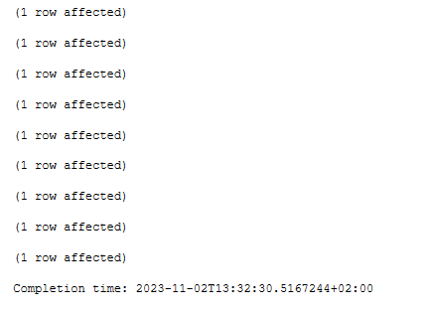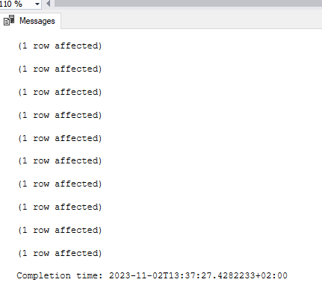

Create Procedure SelectAllEmployees

as

Select \* from Dbo.Employee

go;

SELECT Company.Name, Projects.Specialist

FROM Dbo.Company

INNER JOIN Dbo.Projects ON Projects.Specialist = Projects.Specialist;

SELECT Company.Name, Projects.Employee

FROM Dbo.Company

INNER JOIN Dbo.Projects ON Company.Name = Projects.Employee;